


TECHNICAL REPORT
NIRMAAN 2026

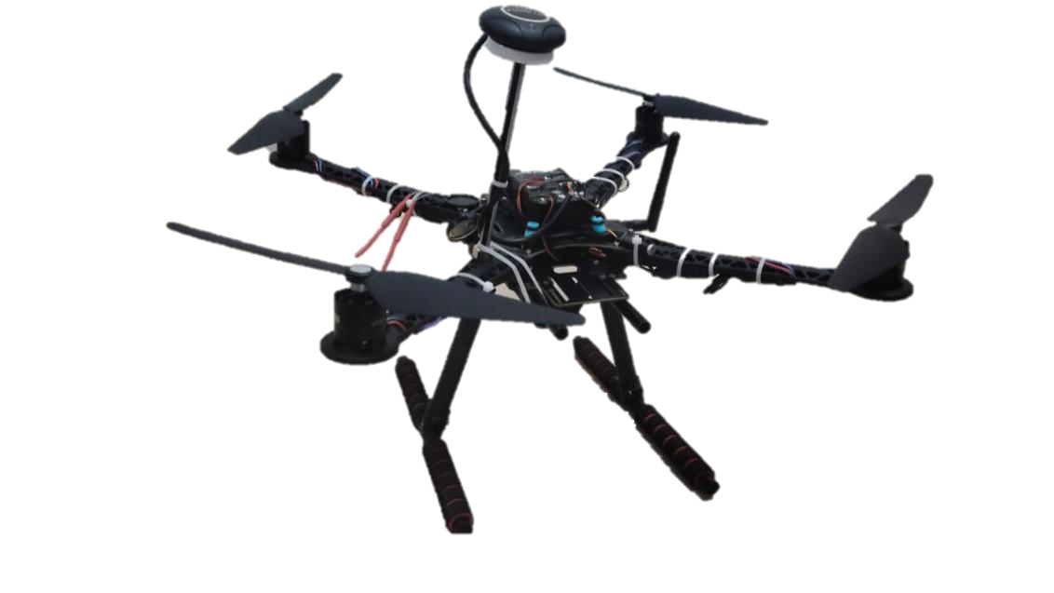

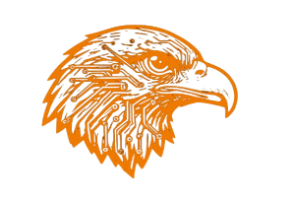
AERONEX

Problem Statement Title - A deployable Al-powered autonomous drone that aids search-and-rescue operations by detecting people and hazards, thereby Improving responder safety and reducing victim discovery time.

Table of Contents

1.0 Introduction.....................................................................................2

1.1 Objectives…………….......................................................................... 3

1.2 MissionProfile................................................................................. 3

2.0 Conceptualization and Design Selection Process.............................. 3

3.0 Preliminary Weight Estimation........................................................ 5

3.1 Selection of Propulsion System....................................................... 5
3.1.1 Selection of Motor........................................................................ 5
3.1.2 Battery and Endurance Estimation……………………....……………………. 6

3.2 Avionics Subsystem Selection.......................................................... 8
3.2.1 Selection of Flight Controller......................................................... 8
3.2.2 Selection of Flight Computer......................................................... 9
3.2.3 Navigation System....................................................................... 9
4.0 Bill of Materials ............................................................................. 9
5.0 Autonomous Flight Simulation ...................................................... 13
6.0 Innovations ...................................................................................11
7.0 Safety Measures ........................................................................... 21
8.0 Conclusion .................................................................................... 22

1.0 Introduction

1.1 Objectives
The Internal Smart India Hackathon 2026 requires the team to design, develop, and demonstrate an Unmanned Aerial Vehicle (UAV) capable of autonomous mission execution for real-world payload delivery tasks. The team focuses on achieving high efficiency, low navigation and control error, and robust flight stability while maintaining practical manufacturability and commercial viability of the platform.

1.2 Mission profile:
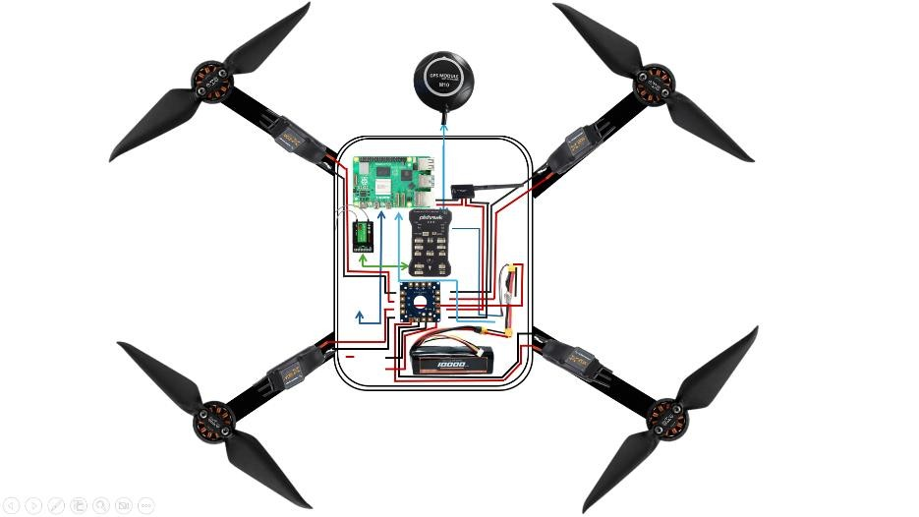
The autonomous UAV is made for detection of living creatures which stuck in flood, waiting for rescue and medication. Our UAV can search them and give their geotag location or provide a first aid kit. Rescuers can continuously monetize the mission’s live feed.

2.0 Conceptualization and Design Selection Process
In the early design phase, the team reviewed relevant UAS literature and shortlisted feasible multirotor layouts. A structured Pugh chart evaluation was then used to compare configurations against key parameters and select the most suitable frame for the mission.

Parameters | Score(/5) | Quad X |  | Quad+ |  | Quad H |  | Hexacopter
 |  | Score | Total | score | Total | score | Total | Score | Total
Stability | 5 | 4 | 20 | 3 | 15 | 4 | 20 | 5 | 25
Power Consumption | 2 | 4 | 8 | 4 | 8 | 3 | 6 | 2 | 4
Manufacturability | 3 | 4 | 12 | 4 | 12 | 3 | 12 | 2 | 6
Manoeuvrability | 3 | 5 | 15 | 2 | 6 | 4 | 12 | 2 | 6
Fragile Payload Drop | 5 | 5 | 25 | 3 | 15 | 4 | 20 | 4 | 20
Total |  |  | 80 |  | 56 |  | 70 |  | 61

-: Comparison Table for Multirotor :-

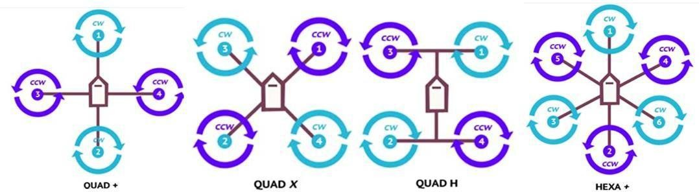

-: Types of Multirotor Configuration :-

3.0 Preliminary Weight Estimation
Components | Weight approximation(kg)
UAV frame | 0.47
Motors | 0.25
ESC’s | 0.084
Battery | 0.590
Flight controller + computer | 0.14
Telemetry + Receiver + GPS module | 0.087
Auxiliary weight | 0.17
Total UAV Weight | 1.791

3.1 Selection of Propulsion System

3.1.2 Selection of Motor
Motors are critical components of a UAV in analysing performance and its potential under various circumstances. For selection of optimal motor, the essential parameters are listed in Table 5 which shows the comparison of various motors.
Motor | Weight  (g) | Voltage (V) | Current (A) | Power (W) | Thrust (g) | Propeller (inch) | Efficiency (g/W)
T-motor  MN3110700kv | 99 | 16.8 | 14.0 | 235.2 | 1290 | 12*4.5 | 5.48
Emax ECOII22072400kv | 33.5 | 16.8 | 41.8 | 702.24 | 1610 | 5*5 | 2.29
T-motor Air gear 450II920kv | 62 | 16.8 | 16.3 | 260 | 1332 | 10*4.5 | 5.3
Sunnysky A2212980kv | 56 | 16.8 | 16.6 | 278.88 | 1220 | 9*4.5 | 4.37

Considering key parameters and the manufacturers’ datasheet, T-motor Air-gear 450II 920Kv motor paired with 10*4.5 inches propeller was selected. Additionally, to ensure the safe current regulations of motor without affecting the motors speed. The team decided to choose HobbyWing 20A ESC. It is known for its extensive safety features, including low-voltage cutoff, thermal protection and signal loss protection, which assures safe operation and efficient power management by reducing heat buildup and extending run time.

3.1.3 Battery and Endurance Estimation
Battery selection is driven by a quantitative assessment of total system power demand, accounting for operating voltage and current drawn across all subsystems during critical conditions. The overall on-board power requirement is determined by aggregating the power consumption of each subsystem, enabling an optimized power system design for improved performance and flight endurance.
Table: Power Consumption of each component
Components | Power Consumed
Components | Power(W) | Quantity | Total  power(W)
Motors | 260 | 4 | 1040
Flight Controller | 15 | 1 | 15
On-board Flight Computer | 25 | 1 | 25
Total |  |  | 1080

Capacity = Total Power (W) × Time (h) - Capacity = 1080 × 0.25 = 270 Wh

Operating at a nominal voltage of 14.8 V (4S 2P configuration) required battery capacity is derived using an energy-balance model accounting for motor load, miscellaneous power, flight duration, and thrust-to-weight ratio:

((𝐏 × 𝟒) + 𝐌) × 𝐭) ((𝟐𝟔𝟎 × 𝟒) + 𝟒𝟎) × 𝟎. 𝟐𝟓
𝑪 = − −(𝟐) 𝑪 = = 𝟕. 𝟒𝟏𝟓𝑨𝒉
𝐕 × (𝐓/𝐖) 𝟏𝟒. 𝟖 × (𝟐. 𝟒𝟔)

where, V=Voltage, P=Power at 100% throttle, C=Battery capacity, M=Miscellaneous power, t=Time in hours, T/W =Thrust-to-weight ratio
Table 8: Current consumed by individual components.
Components | Current Drawn
Components | Current (A) | Quantity | Total current(A)
Motors | 16.3 | 4 | 65.2
Flight Controller | 3 | 1 | 3
On-board Flight Computer | 5 | 1 | 5
Total |  |  | 73.2

The combined current demand across all subsystems is 73.2A With an estimated battery requirement of 7415 mAh .The minimum required continuous discharge rate is therefore :

𝐈 𝟕𝟑.𝟐
C-rating = C-rating = = 9.87C
𝐂 𝟕.𝟒𝟏𝟓

Where I=Total Current, C=Battery Capacity

3.2 Avionics Subsystem Selection

3.2.1 Selection of Flight Controller
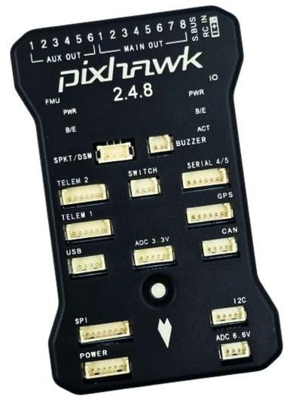
The flight controller, the Pixhawk 2.4.8 is the embedded control unit of your UAV. The flight controller stabilises the UAV guides it and manages the aircraft in time. The flight controller receives data from sensors such as the IMU (accelerometer and gyroscope) magnetometer, barometer and GPS.

The flight controller fuses this data. Runs flight-control algorithms. The flight controller constantly calculates the attitude, angular rates, position and altitude corrections. The flight controller then creates PWM, for the four ESCs based on the Quad-X motor mixing rules so that the UAV can adjust roll, pitch, yaw and thrust separately. The flight controller also handles arming and disarming failsafe logic, flight modes, battery monitoring, parameter management GPS navigation and autonomous missions.

3.2.2 Selection of Flight Computer
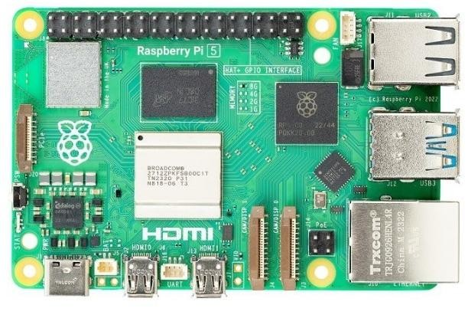
The Flight Computer is used as the companion computer. It works with the Pixhawk 2.4.8. It provides level computational capabilities such as computer vision, AI/YOLO object detection, autonomous path planning, sensor processing, missionlevel decision making. These tasks are beyond the real-time flight-control capabilities of the Pixhawk.
The RPI5 can communicate with the Pixhawk through MAVLink over UART. It uses software such as MAVSDK. It sends high-level commands such as arm, takeoff, waypoint navigation, velocity commands and landing. The Pixhawk handles the low-level attitude stabilization, motor mixing, PID control loops, sensor fusion and actuator outputs

3.2.3 Navigation System
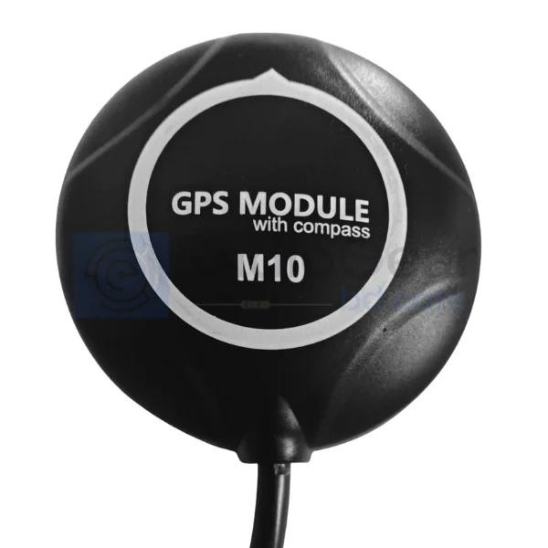
The M10 GNSS navigation system provides the drone with position, speed, height and time information derived from signals received from global navigation satellite constellations such as GPS, Galileo, GLONASS and BeiDou.
The M10 GNSS navigation system supplies latitude, longitude and height coordinates along with ground speed to the Pixhawk 2.4.8.
There the M10 GNSS navigation system data is merged with IMU readings and other sensor measurements through EKF sensor fusion to produce an estimate of the drone’s state. The M10 GNSS navigation system is crucial for tasks such, as holding position returning to launch following waypoints
carrying out missions respecting geofences and performing precise outdoor navigation. Additionally the M10 GNSS navigation system offers a position reference allowing the flight controller to correct any drift.

4.0 Bill of Materials
Based on the specifications the team has decided on the cost breakdown for both electronic and mechanical components as shown in the Table 9 and 10 respectively.

Components Rate (Rs.) Quantity Total Amount (Rs)
T Motors Air Gear 450 Combo 1800 4 7200
Flysky FS-i6S Transmitter 4988 1 4988
Flight Controller 6929 1 6929
FS-iA10B 10CH Receiver | 2019 | 1 | 2019
Neo M10 GPS | 2589 | 1 | 2589
GPS Stand / Holder | 289 | 1 | 289
Telemetry | 6853 | 1 | 6853
Custom Li-ion battery | 481 | 8 | 3848
Drone Frame Kit | 3379 | 1 | 3379
Power Module | 579 | 1 | 579

Total Components Amount = 38673

5.0 Autonomous Flight simulation
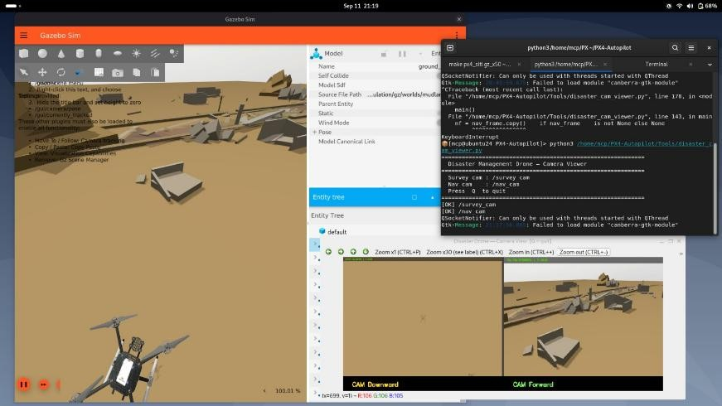
The autonomous UAS mission was simulated using Gazebo as the primary 3D simulation environment to support the development and validation of the autonomous aerial system.

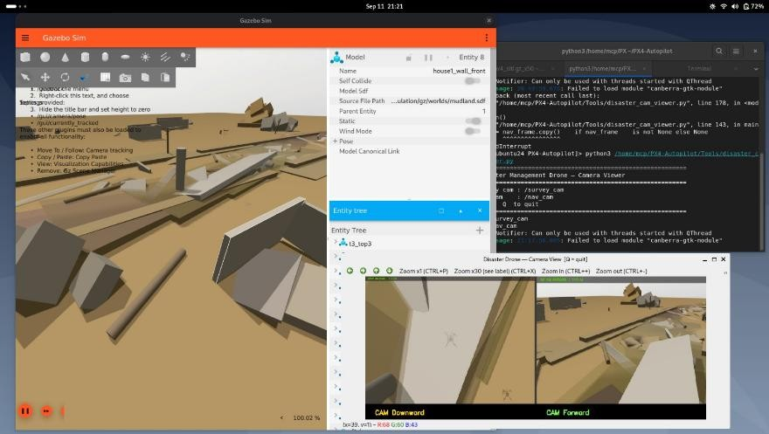
The complete autonomous mission logic was executed through a MAVSDK-Python–based control architecture, where the mission script handled navigation, waypoint management, replanning, and mission-state transitions.

The UAS flight dynamics were simulated using PX4 Software-in-theLoop (SITL), enabling realistic interaction between the virtual drone and the MAVSDK-based mission system through MAVLink communication.

➢ Selection of Radio Telemetry
Radio telemetry enables data transmission between the quadcopter and ground control station using electromagnetic waves. Through the MAVLink protocol, it relays real-time information such as altitude, speed, battery status, and GPS position, allowing the pilot to monitor the vehicle and adjust flight parameters efficiently. For control, the team utilizes the Radiomaster Flysky FS-i6S 2.4GHz 10CH AFHDS 2A RC Transmitter paired with the FS-iA10B 10CH Receiver, providing a range of up to 1.5 km at 2.4 GHz. Additionally, the 3DR Radio Telemetry module is employed for communication, offering an approximate range of 2.5 to 3 km at 915MHz.

➢ Specification of the Radio Telemetry
Modulation Type | GFSK
Band-Range(GHz) | 2.4-2.48
Sensitivity (dBm) | 105dbm (Receiver)
Band-width (KHz) | 500
Operating-Voltage (VDC) | Receiver: 5V;  Transmitter: 12V;
Antenna Length (mm) | 26
Code type | Digital
DSC Port | PS/2 Port PPM
RF Power | Less than 20 dbm
Dimensions (mm) L*W*H | 179*161*81
Weight | Tx: 410 gm  Rx: 15 gm
No. of Channels | 6
Low Voltage Warning | Yes (at less than 9V)
Charging Port | Yes

6.0 Innovation

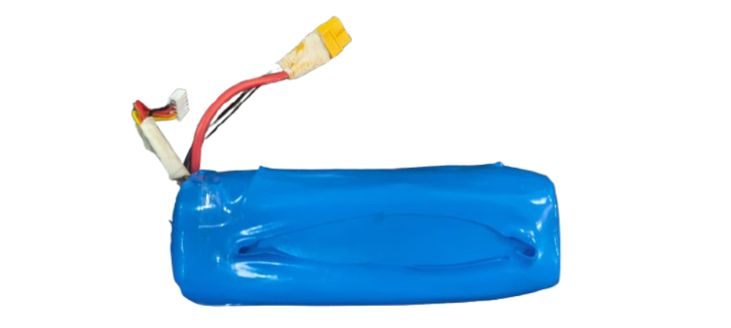
1. Custom battery
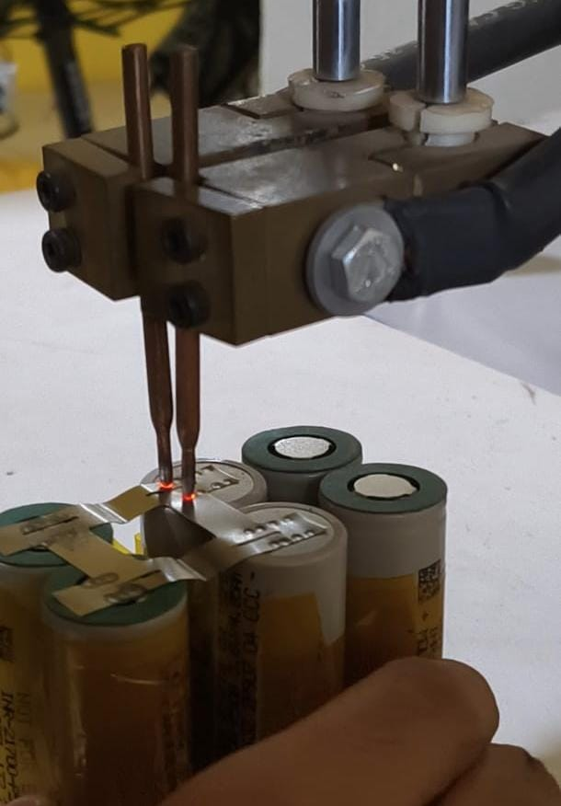
A custom 4S2P battery pack was designed and fabricated using Molicel INR-21700-P45B cells, delivering a nominal voltage of 14.8V, a capacity of 9Ah, and a peak discharge rate of 10C — all under 600g, offering a superior gravimetric energy density compared to most commercially available drone batteries.

This custom battery gives 18.5 mins of flight time.

2. Custom motor driver
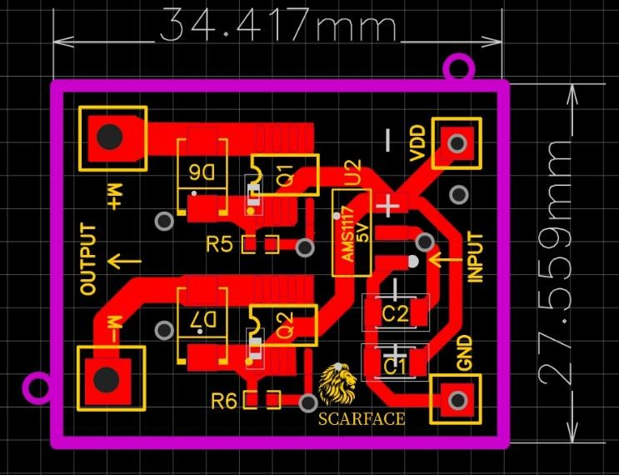
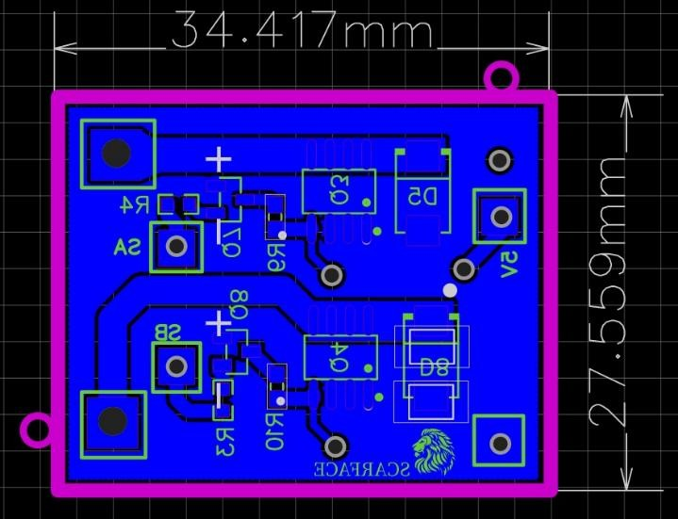
To enable precise payload deployment and retrieval, an electromechanical pulley-based actuation system was developed as a controlled alternative to conventional single-use drop mechanisms. A DC motor coupled to a pulley provides bidirectional torque for deterministic lowering and retraction of the payload, improving positional accuracy and repeatability across successive operations.
The custom motor driver was designed in place of a commercial motor drivers to meet the specific current requirements of the DC motor. The driver implements a MOSFET-based H-bridge topology with a modified servo interface, enabling direct PWM acquisition from the flight controller and translating control signals
into discrete switching states for bidirectional motor operation. High-side P-channel and low-side N-channel MOSFETs facilitate efficient polarity reversal across the motor terminals, while integrated flyback diodes clamp inductive voltage transients during commutation, protecting the switching devices from overvoltage stress.
This architecture minimises component overhead and reduces board space and mass compared to commercially available alternatives — delivering a compact, tightly integrated actuation solution well-suited for weight-sensitive quadcopter applications.

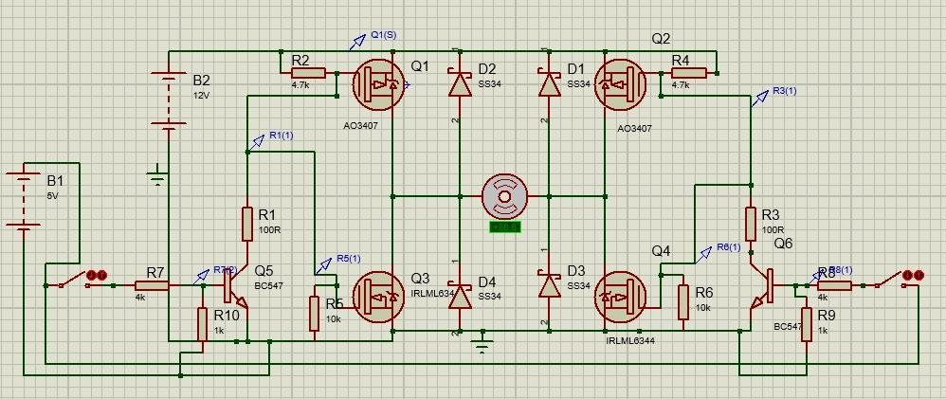

Custom Automatic Charging Station

Each grid cell uses an independent MOSFET-based switching circuit to connect the cell to either +17 V or GND according to the detected landing condition. The LM393 comparator generates the control signal, while 2N7000 N MOSFETs drive the power MOSFETs. IRF4905 acts as the high-side switch for +17 V, while Q1 IRFZ44N acts as the low-side switch for GND.

The PMOS gate is biased and protected using a Zener-diode clamp, which limits the gatesource voltage to a safe value. The NMOS gate is biased using a resistor voltage divider, providing the required gate voltage while keeping the NMOS OFF by default before drone landing.
The identical per-grid circuits form a modular charging architecture, allowing the station to be foldable, portable, and easy to maintain, with each grid independently switched according to the drone’s landing configuration.
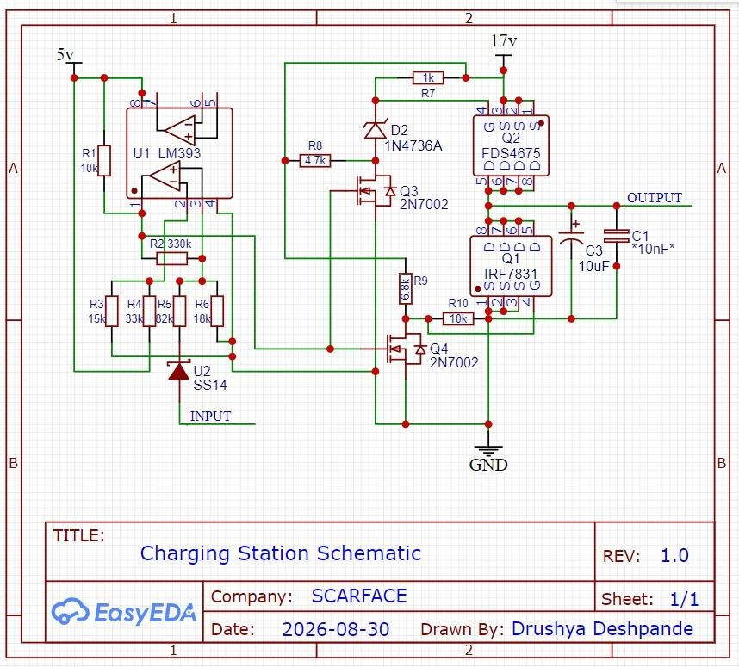
Charging Station Schematic

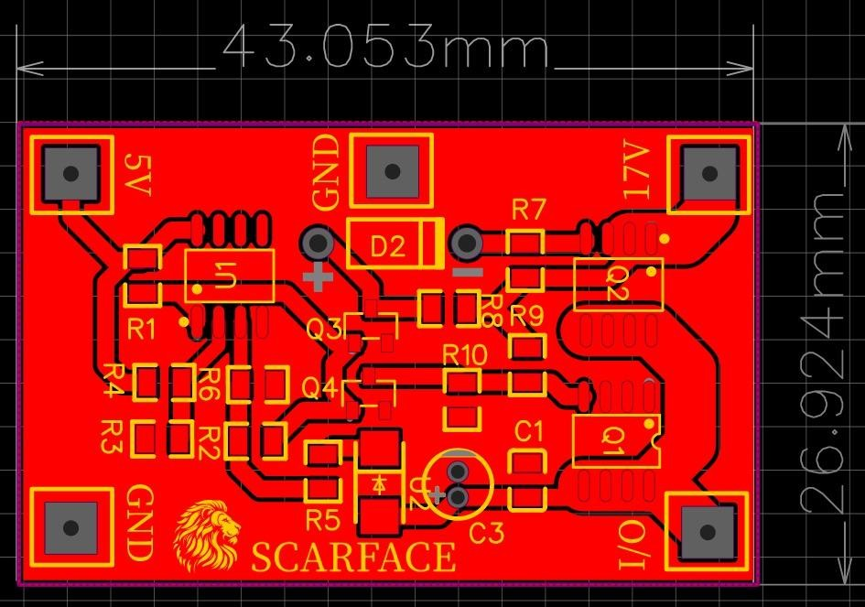

PCB design of charging station (SMD version)
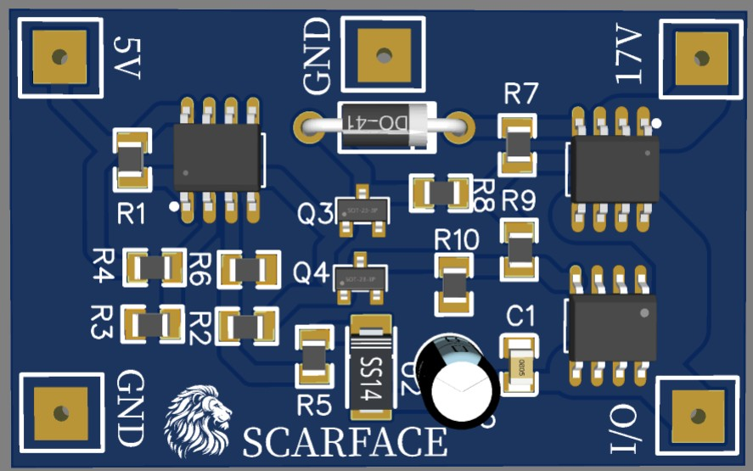
3D view : PCB design of charging station (SMD version)
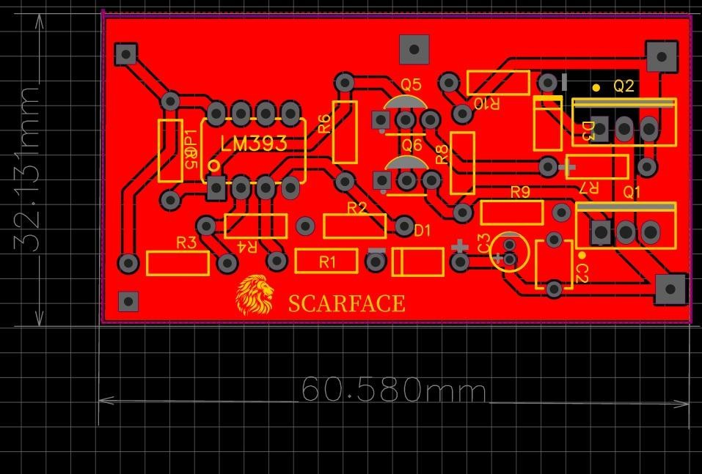

PCB design of charging station (THT version)
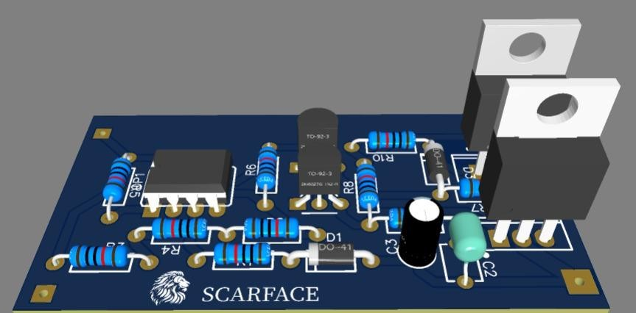
3D view : PCB design of charging station (THT version)

Given Values
Parameter | Value
LM393 supply | VCC = 5 V
R1 | 10 kΩ
R2 (feedback) | 330 kΩ
R3 | 15 kΩ
R4 | 33 kΩ
R5 | 82 kΩ
R6 | 18 kΩ
Maximum input | 16.8 V
Assumed diode drop | VD ≈ 0.7 V

1. Reference Voltage at Pin 2
R4 and R3 form the reference divider.
VREF = $\frac{VCC × R3 }{(R3 + R4)}$
VREF = $\frac{ 5 × 15k }{(15k + 33k)}$
VREF = $\frac{5 × 15 }{48}$
VREF = 1.5625 V
Therefore, Pin 2 = 1.5625 V.

2. Reference-Divider Current
IREF = VCC / (R3 + R4)
IREF = 5 / 48k
IREF = 104.17 µA

3. Input Voltage After D1
Assuming D1 has a forward voltage of approximately 0.7 V:
VIN,D1 = VIN − VD At VIN = 16.8 V:
VIN,D1 = 16.8 − 0.7 = 16.1 V

4. Pin 3 Signal Voltage
Ignoring the feedback effect of R2 for this initial signal calculation:
V3 = VIN,D1 × R6 / (R5 + R6)
V3 = 16.1 × 18k / (82k + 18k)
V3 = 16.1 × 18 / 100
V3 = 2.898 V
Thus, at 16.8 V input, the divider signal is approximately 2.898 V.

5. Feedback Resistor R2 and Switching Threshold
R2 = 330 kΩ provides positive feedback from the LM393 output to Pin 3, creating hysteresis and two switching thresholds.
At the exact switching point, the comparator inputs are equal:
V3 = V2 = VREF = 1.5625 V

Therefore, 1.5625 V is used for V3 in the threshold calculation. The 2.898 V value is the Pin-3 divider voltage at 16.8 V input when the R2 feedback effect is ignored.

6. Upper Threshold — Input Rising

When the LM393 output is LOW, VOUT ≈ 0 V.
(VIN,D1 − VREF)/R5 + (VOUT − VREF)/R2 = VREF/R6 (VIN,D1 − 1.5625)/82k + (0 − 1.5625)/330k = 1.5625/18k Solving gives VIN,D1 ≈ 9.07 V. VIN(UPPER) = 9.07 + 0.7 ≈ 9.77 V Upper threshold ≈ 9.77 V.

7. Lower Threshold — Input Falling
When the LM393 output is HIGH, VOUT ≈ 5 V.
(VIN,D1 − VREF)/R5 + (VOUT − VREF)/R2 = VREF/R6
(VIN,D1 − 1.5625)/82k + (5 − 1.5625)/330k = 1.5625/18k
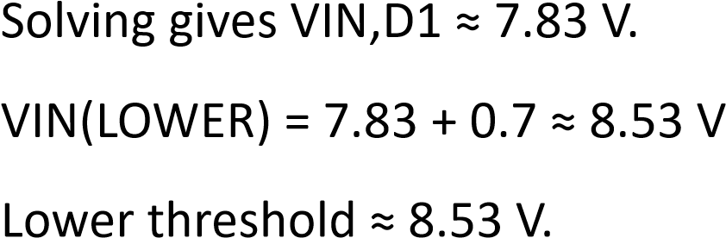

8. Hysteresis Voltage
VH = VTH(UPPER) − VTH(LOWER)
VH = 9.77 − 8.53
VH ≈ 1.24 V

Feedback Resistor Calculation
The following calculation is added from the handwritten calculation provided.

1. Feedback Resistor Calculation
The feedback resistor can be estimated using the required hysteresis voltage:
Rf = R1 × (VOH − VOL) / ΔV
Using R1 = 82 kΩ, VOH = 5 V, VOL ≈ 0 V, and ΔV = 1.21 V:
Rf = 82 × 10³ × 5 / 1.21
Rf ≈ 338.84 × 10³ Ω
Rf ≈ 330 kΩ
Therefore, a standard 330 kΩ resistor is a practical selected value.

2. Voltage Contribution with 330 kΩ Feedback Resistor
Using the selected 330 kΩ feedback resistor, the approximate voltage contribution is:
ΔV ≈ R1 × VOH / Rf
ΔV ≈ 82 kΩ × 5 V / 330 kΩ
ΔV ≈ 1.24 V
Thus, the 330 kΩ feedback resistor produces approximately 1.24 V of hysteresis contribution, which is close to the required 1.21 V.

Final Results
Parameter | Value
Reference voltage, Pin 2 | 1.5625 V
Reference-divider current | 104.17 µA
Pin 3 at 16.8 V input (without R2 feedback) | 2.898 V
Upper input threshold | ≈ 9.77 V
Lower input threshold | ≈ 8.53 V
Hysteresis | ≈ 1.24 V

Note: Thresholds assume D1 ≈ 0.7 V and LM393 HIGH output ≈ 5 V. Actual values can vary with diode forward voltage and output behavior.

7.0 Safety Measures
Failsafe Mechanism | Trigger Condition | System Response / Action
Battery Failsafe | The system triggers when voltage drops below the threshold or capacity falls below 20%. | The drone executes Return to Launch (RTL) to land safely before power is depleted.
RC Failsafe | It activates if the transmitter signal is lost for more than 1 second. | The flight controller switches to RTL mode to return the vehicle to the home point.
Geofence Failsafe | This triggers if the UAV breaches the pre- | The system motion immediately and executes an RTL command.
 | defined altitude or radius boundaries.
GCS Failsafe | It activates upon the sustained loss of the telemetry link with the ground station. | The drone initiates RTL or lands to ensure it remains within a recoverable range.

8.0 Conclusion
Based on the technical report the proposed system uses a Quad-X UAV platform with a Pixhawk 2.4.8 flight controller, a Raspberry Pi 5 companion computer, a Neo M10 GNSS module, MAVLink/MAVSDK communication and PX4 SITL–Gazebo simulation to perform autonomous search-and-rescue operations. The T-Motor Air Gear 450II 920KV propulsion system paired with 10×4.5-inch propellers delivers thrust to support the 1.791 kg UAV while the custom 4S2P Molicell INR-21700P45B battery ensures about 18.5 minutes of flight time.
The Pixhawk handles real-time attitude stabilization, sensor fusion, PID control, motor mixing, navigation and failsafe functions. The Raspberry Pi 5 adds capabilities such as computer vision, YOLO-based object detection, path planning and mission-level decision making. The M10 GNSS provides position, velocity and altitude data for EKF-based state estimation and autonomous navigation.
Autonomous mission logic was tested using PX4 Software-in-the-Loop and Gazebo simulations with MAVSDK-Python managing waypoint navigation,
replanning and transitions between mission states. A custom electromechanical pulley system enables controlled and repeatable delivery of first-aid supplies. The custom MOSFET H-bridge motor driver allows actuation, with minimal mass and power consumption.
A custom automatic charging station supports autonomous operation through a comparator-controlled MOSFET switching circuit and hysteresisbased battery detection. In total this system brings together flight control, GNSS navigation onboard AI perception, mission planning, payload deployment, telemetry and automated recharging into one integrated UAV solution. The goal is to reduce victim discovery time and enhance responder safety during search-and-rescue missions.

